GATUNDU SOUTH JOINT EXAMINATION

451/1 COMPUTER STUDIES –Paper 1
Kenya Certificate of Secondary Education
2 ½ hours Name………………………………Adm No………
Class…… ….
Instructions to Candidates
- Write your name and admission number in the spaces provided at the top of this page.
- This paper consists of TWO sections; A and B.
- Answer ALL questions in section A.
- Answer question 16 and any other THREE questions from section B.
- All answers should be written in the spaces provided on the question paper.
- This paper consists of 13 printed pages
- Candidates should check the question paper to ascertain that all the pages are printed as indicated and that no questions are missing
For Official Use Only
SECTION | QUESTION | SCORE
A | 1 - 15
B | 16
B | TOTAL
This paper consists of 13 printed pages. Candidates should check the question paper to ascertain that all pages are printed as indicated and that no questions are missing

SECTION A (40 MARKS)

Answer ALL the questions in this section

- State TWO characteristics of fifth generation computer (2 Marks)
…………………………………………………………………………………………………..
…………………………………………………………………………………………………..
…………………………………………………………………………………………………..
- The following number was entered by a computer user into a system 5.66894 and the first time it displayed 5.66 on the screen, he entered it again and it displayed 5.67; explain the type of errors that occurred during data processing (4 marks)
…………………………………………………………………………………………………..
…………………………………………………………………………………………………..
…………………………………………………………………………………………………..
…………………………………………………………………………………………………..
…………………………………………………………………………………………………..
- Describe any TWO elements of a computer file. (2 marks)
…………………………………………………………………………………………………..
…………………………………………………………………………………………………..
…………………………………………………………………………………………………..
…………………………………………………………………………………………………..
…………………………………………………………………………………………………..
…………………………………………………………………………………………………..
- Identify the following tools associated with DTP (3 marks)



- State three risks posed by improper cabling in a computer laboratory (3marks)
…………………………………………………………………………………………………..
…………………………………………………………………………………………………..
…………………………………………………………………………………………………..
…………………………………………………………………………………………………..
…………………………………………………………………………………………………..
…………………………………………………………………………………………………..
- Study the word processor screenshot below and answer the questions that follow
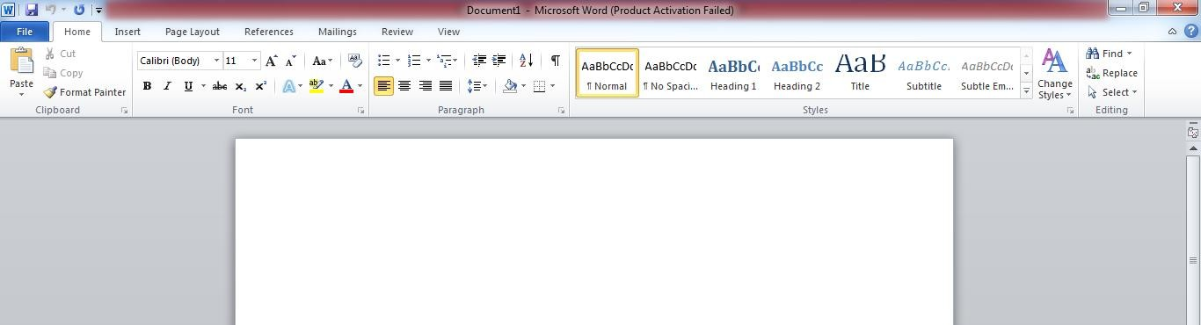

A B

  - Give the relevance of the part labelled (2 marks)

i. A
…………………………………………………………………………………………………..
ii. B
…………………………………………………………………………………………………..

  - Identify any two icons you could use as paragraph formatting tools from the diagram above (state their names) (2marks)
…………………………………………………………………………………………………..
…………………………………………………………………………………………………..
…………………………………………………………………………………………………..
- List TWO ways in which computer technology can be used in law enforcement.(2 marks)

…………………………………………………………………………………………………..
…………………………………………………………………………………………………..
…………………………………………………………………………………………………..
- State two characteristics of parallel cables (2 marks)
…………………………………………………………………………………………………..
…………………………………………………………………………………………………..
…………………………………………………………………………………………………..
- File conversion, in system development, refers to modifying or changing the format of files when a new system is introduced e.g. From manual to computerized. State any three factors considered before the file conversion process. (3 marks)

…………………………………………………………………………………………………..
…………………………………………………………………………………………………..
…………………………………………………………………………………………………..
- Differentiate between the following in relation to data security and control (4 marks)
- Password and Biometric Authentication.
…………………………………………………………………………………………………..
…………………………………………………………………………………………………..
…………………………………………………………………………………………………..
- Privacy and Confidentiality.
…………………………………………………………………………………………………..
…………………………………………………………………………………………………..
…………………………………………………………………………………………………..
- Peter would like to send photos to Jennifer via e-mail. Outline the steps Peter would follow to send the photos as file attachments (3marks)
…………………………………………………………………………………………………..
…………………………………………………………………………………………………..
…………………………………………………………………………………………………..
…………………………………………………………………………………………………..
………………………………………………………………………………………………….
- With the increase in use of electronic communication, many different forms of communication has been introduced. Distinguish between webcasts and webinars (2 marks)
…………………………………………………………………………………………………..
…………………………………………………………………………………………………..
…………………………………………………………………………………………………..
…………………………………………………………………………………………………..
- State three reasons why it is important to define data types of fields in a database correctly. (3 marks)
…………………………………………………………………………………………………..
…………………………………………………………………………………………………..
…………………………………………………………………………………………………..
…………………………………………………………………………………………………..

- Explain two benefits that the employer will get by allowing a worker to do the office work through telecommuting.. (2 marks)
…………………………………………………………………………………………………..
…………………………………………………………………………………………………..
…………………………………………………………………………………………………..
…………………………………………………………………………………………………..

- What is the meaning of IP address as used in networking. (1 mark)

…………………………………………………………………………………………………..
…………………………………………………………………………………………………..
…………………………………………………………………………………………………..

SECTION B (60 marks)

Answer question 16 and any other THREE questions from this section in the spaces provided.
- a) State any THREE differences between an Interpreter and a Compiler (3 marks)

Compiler | Interpreter
- State the best application area for each of the following languages. (2marks)
  - FORTRAN
…………………………………………………………………………………………

  - BASIC
…………………………………………………………………………………………
  - OCCAM
…………………………………………………………………………………………
  - PHP
…………………………………………………………………………………………

- Study the flowchart below and answer the questions that follow:

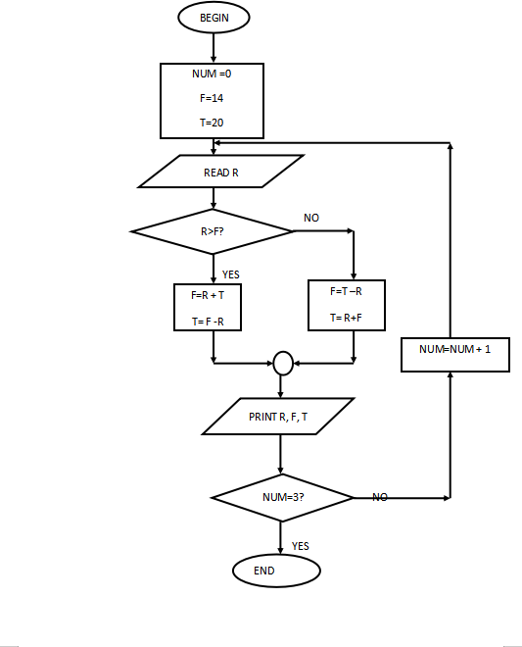

- What would be the output if the following values were input; 40, 20, 15, 1 (2 marks)

…………………………………………………………………………………………………..
…………………………………………………………………………………………………..
…………………………………………………………………………………………………..
…………………………………………………………………………………………………..
…………………………………………………………………………………………………..

- . Write a pseudocode for the flowchart above (8 marks)

17(a) State three instances with reason where the use of scanners is highly preferred than keyboards as a method of data entry. (6marks)
…………………………………………………………………………………………………..
…………………………………………………………………………………………………..
…………………………………………………………………………………………………..
…………………………………………………………………………………………………..

(b) State the meaning of the phrase ‘PLUG AND PLAY’as used with computer systems:.
(2 marks)
…………………………………………………………………………………………………..
…………………………………………………………………………………………………..
…………………………………………………………………………………………………..
- List an input device appropriate for each of the following tasks: (3 marks)

I) A Biology Teacher wants to upload a picture of a new plant species into her laptop;

…………………………………………………………………………………………………..
- A construction engineer wants to upload her hard copy house plan into the computer;

…………………………………………………………………………………………………..

- A musician wants to record his audio music into the computer;

…………………………………………………………………………………………………..
- State any two application areas of USB cables which makes them more popular than other cables. (2 marks)

…………………………………………………………………………………………………..
…………………………………………………………………………………………………..
…………………………………………………………………………………………………..
- List any two tasks that an electronic spreadsheet should be able to perform other than calculations. (2 marks)

…………………………………………………………………………………………………..
………………………………………………………………………………………………….
…………………………………………………………………………………………………..
………………………………………………………………………………………………….

18. (a) Convert the following numbers to Decimal number system
(i) 010011.10001₂ (3marks)
…………………………………………………………………………………………………
…………………………………………………………………………………………………
…………………………………………………………………………………………………
…………………………………………………………………………………………………
…………………………………………………………………………………………………
…………………………………………………………………………………………………
(ii) 36.5₈ (3marks)
…………………………………………………………………………………………………
…………………………………………………………………………………………………
…………………………………………………………………………………………………
…………………………………………………………………………………………………
…………………………………………………………………………………………………
…………………………………………………………………………………………………
…………………………………………………………………………………………………
(b) Evaluate 1010₂+1010₂+1001₂+00010₂-1101₂ (3marks)
…………………………………………………………………………………………………
…………………………………………………………………………………………………
…………………………………………………………………………………………………
…………………………………………………………………………………………………
…………………………………………………………………………………………………
…………………………………………………………………………………………………
…………………………………………………………………………………………………
(c) Using two complements, show how the arithmetic below would be carried on an 8-bit computer system by
subtracting 40₁₀ from 50₁₀ , write your answer in decimal notation. (4marks)
…………………………………………………………………………………………………
…………………………………………………………………………………………………
…………………………………………………………………………………………………

(d) Describe two reasons for the use of Octal and Hexadecimal number system (2marks)
…………………………………………………………………………………………………
…………………………………………………………………………………………………
…………………………………………………………………………………………………
…………………………………………………………………………………………………
19. (a) Name three Data Terminal Equipment used in a computer network (3marks)
…………………………………………………………………………………………………
…………………………………………………………………………………………………
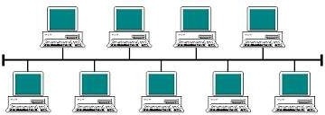
(b) Use the diagram to answer the questions that follow
A
(i) Identify the topology represented in the above diagram (1mark)
…………………………………………………………………………………………………
…………………………………………………………………………………………………
(ii) State the function of the part marked A (2marks)
………………………………………………………………………………………………
…………………………………………………………………………………………………
(iii) Name two limitation of this technology (2marks)
…………………………………………………………………………………………………
…………………………………………………………………………………………………
(c) Name four roles of a Network Administrator (4marks)
…………………………………………………………………………………………………
…………………………………………………………………………………………………
(d) Describe three main pathways in a computer in which components like ALU, Control unit,
Register, Buffer Cache, Main memory use to transfer data and instruction between them (3marks)
…………………………………………………………………………………………………
…………………………………………………………………………………………………
…………………………………………………………………………………………………
…………………………………………………………………………………………………
20. Use the database tables below to answer the questions that follow.

CUSTOMERS TABLE
CUSTOMER NUMBER | NAME | TEL NO
9001 | Jane | 021142123
9002 | Mike | 023545532
9003 | James | 021462112
9004 | Collins | 058421123
9005 | Joseph | 032445512
9006 | Ann | 050112231

ORDERS TABLE
ORDER ID | CUST NO | DATE | AMOUNT
352 | 9001 | 2/5/2023 | 20000
235 | 9002 | 6/4/2023 | 35000
532 | 9003 | 8/6/2023 | 11000
623 | 9004 | 9/6/2023 | 65000
521 | 9005 | 23/6/2023 | 25000
231 | 9006 | 30/6/2023 | 5000

- State the most appropriate data types for each of the following fields (3 mks)
- CUSTOMER NUMBER…………………………………………………………………
- NAME…………………………………………………………………………………
- TELNO…………………………………………………………………………………
- ORDER ID…………………………………………………………………
- DATE………………………………………...…………….
- AMOUNT………………………………………………………………………………
- Determine the most appropriate primary key for each of the above tables. (2 mks) ………………………………………………………………………………………………
………………………………………………………………………………………………
………………………………………………………………………………………………
- List TWO fields that can be used to create a relationship between the two tables. (1mk)
………………………………………………………………………………………………
………………………………………………………………………………………………
………………………………………………………………………………………………
- Identify the foreign key in the above database tables. (1 mk)
………………………………………………………………………………………………
………………………………………………………………………………………………
- During system implementation the management of Spring Supermarket decided to run both the old system and the new system concurrently for sometime.
- Give the name of the changeover strategy that was used by the management of
Spring Supermaket. (1 mk)
………………………………………………………………………………………………
………………………………………………………………………………………………
………………………………………………………………………………………………

(ii) State any TWO disadvantages of the above changeover strategy. (2mks)

………………………………………………………………………………………………
………………………………………………………………………………………………
………………………………………………………………………………………………
………………………………………………………………………………………………
………………………………………………………………………………………………

- Other than changover, list any other TWO activities performed during system
implementation. (2mks)
………………………………………………………………………………………………
………………………………………………………………………………………………
………………………………………………………………………………………………
………………………………………………………………………………………………
………………………………………………………………………………………………
- Explain TWO circumstances that may lead to development of a new information
system (2 mks)
………………………………………………………………………………………………
………………………………………………………………………………………………
………………………………………………………………………………………………
………………………………………………………………………………………………
………………………………………………………………………………………………
(f) Describe the term system entropy (1 mk)
………………………………………………………………………………………………
………………………………………………………………………………………………
………………………………………………………………………………………………

